**NaPDI Repository Experiment Report**

**In Vitro Transport Inhibition Experiment(s)**

**Please fill in all relevant fields to the experiment(s) performed.**

1. **General Information**

|  |  |
| --- | --- |
| **Title of experiment** |  |
| **Research organization** |  |
| **Research organization’s overall effect cutoff** |  |
| **Precipitant name (therapeutic class)** |  |
| **Test system (please see appendix I for options)** |  |

|  |  |  |  |  |
| --- | --- | --- | --- | --- |
| **Experiment number and title** | Object name (therapeutic class) | Object concentration(s)  (µM or µg/mL units preferred) | Transporters involved | Number of experiments conducted |
| **1.** |  |  |  |  |
| **2.** |  |  |  |  |
| **3.** |  |  |  |  |

(Add more rows if needed)

|  |  |
| --- | --- |
| **Additional information (e.g. please describe if precipitant is an extract or fraction of a natural product, etc. )** |  |

**An example of data entered in the repository on the admin side:**

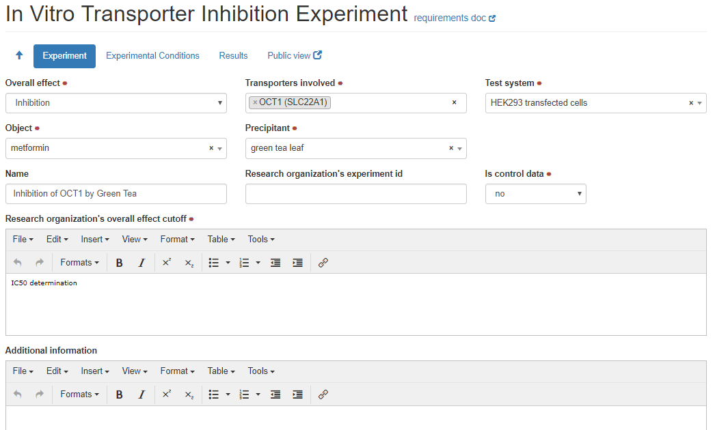

1. **Experimental Conditions**

|  |  |
| --- | --- |
| **Density** |  |
| **Protein concentration or amount/well** |  |
| **Plate type** |  |
| **Number of days (or hours) after plating experiment was conducted** |  |
| **Passage number** |  |
| **TEER threshold** |  |
| **Barrier integrity method** |  |
| **Incubation Time (min units preferred)** |  |
| **Incubation temperature (deg C units preferred)** |  |
| **Incubation pH** |  |
| **Precipitant concentrations tested (µM units preferred)** |  |
| **Precipitant source** |  |

**Additional information regarding experimental conditions:**

|  |  |
| --- | --- |
| **Additional Information** |  |
| **Control conditions** |  |

**An example of data entered in the repository on the admin side:**

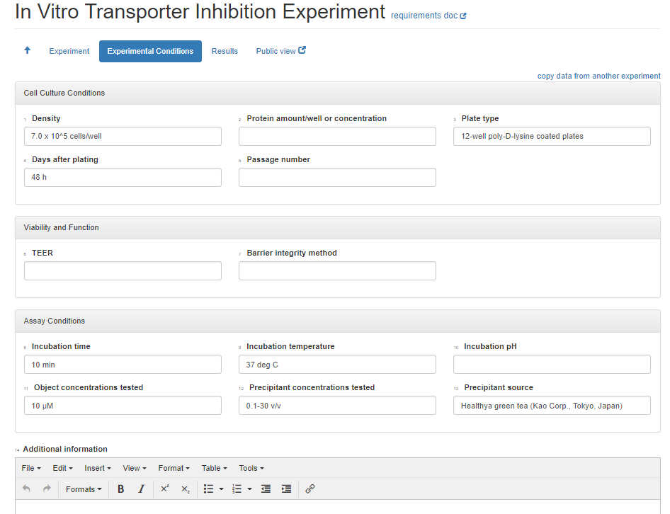

**3. Brief Summary of Results**

**For each experiment, please provide a brief summary of the results and conclusions**

|  |  |  |  |
| --- | --- | --- | --- |
| **Experiment number and title** | **Transport Inhibition type** | **Experiment Type** | **Summary of results**  **(Provide values including units and types, see appendix II and III for details)** |
| 1. | Non-inhibition  Inhibition | Control  Test |  |
| 2. | Non-inhibition  Inhibition | Control  Test |  |
| 3. | Non-inhibition  Inhibition | Control  Test |  |

(Add more rows if needed)

|  |  |
| --- | --- |
| Additional Information |  |
| Conclusions |  |

**Attach relevant figures and tables of results when submitting this form.**

**Appendix I: Transport Test Systems**

* **Transfected/injected/siRNA knock-out cells**
* MDCK-transfected cells
* LLC-PK1-transfected cells
* HEK293-transfected
* HeLa-transfected
* CHO-transfected
* HepG2-transfected
* siRNA knock-out hepatocytes
* siRNA knock-out Caco-2 cells
* siRNA knock-out other cells
* X.laevis Oocytes-injected
* Inside-out membrane vesicles
* **Cell types**
* Hepatocytes
* Primary hepatocytes
* Cryopreserved hepatocytes
* Sandwich cultured hepatocytes
* Intestinal epithelial cells
* Caco-2 cells
* Other cells

**Appendix II: Transport Inhibition Parameters\***

* **Control Parameters**
* **Barrier permeability measurements**
  + Papp A-B vector control
  + Papp A-B transfected
  + Papp A-B Caco-2
  + Papp B-A vector control
  + Papp B-A transfected
  + Papp B-A Caco-2
  + Ratio PappB-A/ PappA-B vector control
  + Ratio PappB-A/ PappA-B transfected
  + Ratio PappB-A/ PappA-B Caco-2
  + Ratio transfected/vector control
  + Permeability rate
  + Efflux rate
* **Uptake measurements**
  + Fold accumulation vector control
  + Fold accumulation transfected
  + Ratio of fold accumulation transfected/vector control
  + Accumulation rate
* **Inhibition Parameters**
* Barrier permeability measurements
  + Papp A-B vector control
  + Papp A-B transfected
  + Papp A-B Caco-2
  + Papp B-A vector control
  + Papp B-A transfected
  + Papp B-A Caco-2
  + Ratio PappB-A/PappA-B vector control
  + Ratio PappB-A/PappA-B transfected
  + Ratio PappB-A/PappA-B Caco-2
  + Ratio transfected/vector control
  + Permeability rate
  + IC50
  + Efflux rate
* **Uptake measurements**
  + Fold accumulation vector control
  + Fold accumulation transfected
  + Ratio of fold accumulation transfected/vector control
  + Accumulation rate
  + Percent Inhibition
  + IC50
  + Ki total
  + Ki unbound
  + Percent bound

* Provide P-values where appropriate, provide value types (see appendix III)

**For Ki values, please provide:

* + Inhibition type:
    - Competitive
    - Non-competitive
    - Uncompetitive
    - Mixed
  + Ki determination method:
    - Linear transformation – Dixon plot
    - Linear transformation - Eadie-Hofstee
    - Linear transformation – Lineweaver-Burk
    - Linear transformation – other
    - Nonlinear least-squares regression
    - Graphic read

**Appendix III: List of value types**

* Mean
* Mean ± SD
* Mean ± SEM
* Mean (range)
* Mean (CV%)
* Mean (CI)
* Median
* Median (CV%)
* Median (range)
* Median (CI)